***Improving Education in Punjab, Pakistan***

# Executive Summary

In this report, we present a comprehensive analysis of school data from various locations across Punjab, Pakistan, with the goal of justifying the allocation of funds for educational initiatives by an international ed-tech company. The company intends to invest 3 million US dollars in Punjab to bridge educational gaps, ensure equal opportunities for all students, and improve infrastructure and facilities.

Our Analysis Focuses on Five Primary Initiatives

1. School Level Upgradation
2. Infrastructure Improvement
3. Facilities Enhancement
4. Expanding Middle and High Schools in Rural Areas
5. Establishing New Primary Level Schools

We have used the provided dataset to understand the current state of education in Punjab and identify areas where the allocated funds can have the most significant impact.

# Data Source and Cleaning

## Data Source

The dataset contains information about schools in Punjab, including school ID, name, location, enrollment, teachers, school upgradation years, school gender, and various other attributes. After research it is found that this data has been take from the official website of School Information System, Government of the Punjab.[1]

## Data Cleaning

We conducted data cleaning to handle missing values, ensure data consistency, and prepare it for analysis. Most of the analysis was done on Power BI to draw the insights in the form of dashboard. That’s why the file was imported in Power BI and cleaning was done through Power Query.

This cleaning was done based on assumptions and some of them are mentioned below:

1. The nulls in the columns for Teacher and Non-Teacher staff were replaced by zero.
2. For the Boundary wall column values stating “Yes” and Condition column stated null, we assumed them to be completed. And Boundary wall entries as “No”, the condition was stated as null for all.
3. For the Toilet Column stating 0 and for the same row total Toilets stated as greater than zero, we assumed them to be “Yes” as it is not possible for a school not having a toilet still having a non-zero entry for “Total Toilets” Column. Replaced “0” as “No” and “1” as “Yes”.
4. Same goes for the Column of “Electricity”. All the schools with some electricity sources were assumed to be having electricity supply as “Yes” and “No” for none.
5. Same goes for the Column of “Drinking Water”. All the schools with some Water sources were assumed to be having a water supply as “Yes” and “No” for none.

# Dataset Analysis

The Dashboard layout was constructed in such a way that it addresses the maximum of the questions for our analysis.

: Major Viewpoint Dashboard

## Total Number of Schools

There is a total of 48,191 schools in the dataset as shown by the count of schools in Dashboard illustrated in Figure 1.

## Lowest Male and Female Students by School Level (2000s)

We identified the schools established in the 2000s with the lowest enrollment for both male and female students. Using the slicers of years and Gender along with Bottom N filter narrowed the schools for lowest number of enrollments for both Genders.

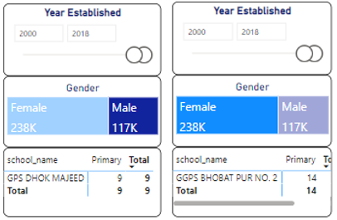

: Schools with lowest enrollment in 2000s

According to analysis, GPS Dhok Majeed and GGPS Bhobat pur No. 2 are the schools having the enrollments 9 and 14 in 2000s located in Attock and Lodhran respectively. Both of the schools are primary level.

## Top 5 Districts with the Highest Number of Teachers and Non-teachers

We determined the districts with the highest number of teachers and non-teachers in schools as shown in the figure below. Rajanpur topped the list of highest number of Teacher staff while Lodhran topping the non-Teacher staff list.

: Districts with Highest Teacher and non-Teacher staff

## School Level and Medium with the Lowest Functional Classrooms

We explored the school levels and mediums with the lowest number of functional classrooms. sMosque has the lowest and Higher Secondar Schools with second lowest number of functional classrooms. On the other hand, English Medium Schools has the lowest number of functional classrooms.

: Lowest Functional classrooms analysis

## Distribution of Teachers Across Different Schools

We created a chart to visualize the distribution of teachers across different schools.

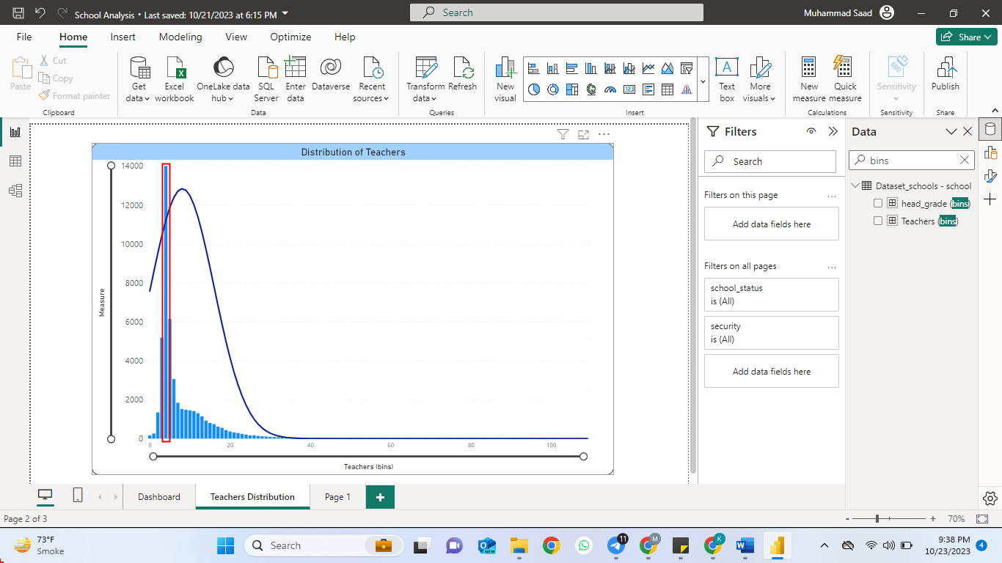

: Distribution of Teachers across schools

The Distribution shows that a maximum of the schools have 5 Teachers in their faculty.

## Male and Female Student Count

Observing the dashboard in Figure 1 shows that the count of male and female students.

Male Student: 6,225K

Female Students: 5,757K

## Schools in Rural and Urban Areas

We counted the number of schools in rural and urban areas as follows from the dashboard.

Urban Areas: 5,775

Rural Areas: 42,416

## Language Level Percentage

Calculated the percentage offering Urdu and English medium education.

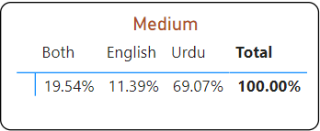

: Percentages of Schools w.r.t language medium

## Districts with Highest Enrollment since establishment

We identified the districts with the highest enrollment in primary, secondary, and higher secondary schools since their establishment.

|  |  |  |
| --- | --- | --- |
| ***School Level*** | ***District of Highest Enrollments*** | ***Enrollments*** |
| Primary | Rahimyar khan | 257968 |
| Secondary | Faisalabad | 362868 |
| Higher Secondary | Faisalabad | 99227 |

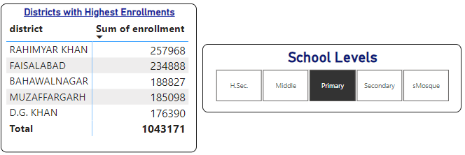

: Primary Schools Enrollment

: Secondary Schools Enrollments

: Higher Secondary Schools Enrollments

## Distribution of Schools by School Level

We created a bar chart representing the number of schools categorized by school level. It indicates that Primary schools have the highest number of schools covering the 66.5% of total.

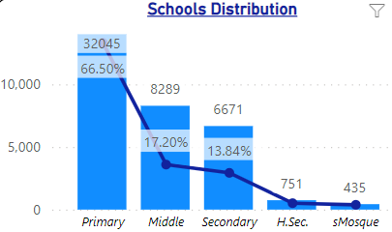

: Schools Distribution by School Level

## Distribution of Students by Gender

We generated a bar chart to showcase the number of students categorized by gender.

: Number of Students (Gender)

## School Ownership

A table was created to showcase school ownership statistics. It shows that most of the schools are owned by the education department which is almost the 95% of all schools.

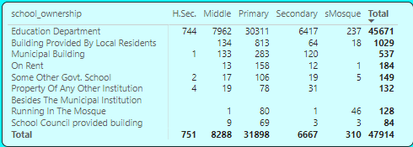

: Schools Ownership Segregation

## Building Conditions

Almost 75% of the schools have satisfactory school building conditions.

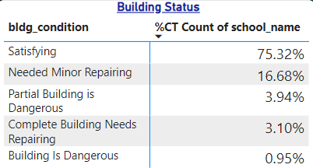

: Satisfactory Building Status

## Security Measures

We calculated the number of schools with satisfactory security measures.

: Schools with Satisfying Security Facility

## Availability of Facilities

5 districts with the lowest availability of drinking water, electricity, boundary walls, and toilets in schools can be seen from the dashboard.

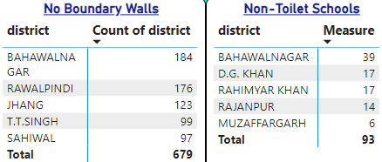

: Districts with less facility

# Justification for Allocation of Funds

Educational initiatives are very necessary for improving the grassroot level education. If Government or a country wants to prosper there must be enough resource of talent in that country and this is only possible if that talent is identified and polished from the very start of schooling. Gone are the days when students with matriculation and intermediate studies can be at satisfactory job levels. For their better future, for the country’s better prospects, it is necessary that quality education is ensured. This is only possible if good educational initiatives are made. The following justifications address some necessary and immediate educational initiatives and pinpoint their importance.

## School Level Upgradation

If we see the analysis above, most of the schools (66.5%) are primary and that means classes are only up to Grade 5. After that students must get enrolled in any of the middle, secondary or higher secondary schools. The educational system in Pakistan is so much obsolete that highest share of schools belongs to primary class. With so much advancement all over the world, having primary schools seems to be not a wise decision. All the schools should be either secondary or Higher Secondary covering all grades with (less than or equal to 10 for Secondary and 11-12 for Higher Secondary). This means that all the schools especially primary schools must be upgraded to Secondary Schools so that when a student passes out from a school, he must have minimum qualification of Matric. Good education till matric can develop a thorough understanding of basic concepts and frameworks for higher education.

This will also bring a factor of increased classrooms which will result in cost in the form of facility extension.

## Infrastructure

According to the school’s data 1,293 of schools don’t even have a boundary wall. 707 schools do not have functional classrooms. 131 schools don’t have toilets which is also a big concern for students especially female. There are around 11,832 schools having unsatisfactory building conditions. These infrastructure reforms are very important and are in the best interests for educational improvement in Punjab.

### Boundary Wall

The boundary wall is important for the isolation of school from rest of the community. With distractions and lack of attention in classrooms students may find it really hard concentrating on what they are taught. Also, it is also very necessary for security and peace of mind for teachers.

### Toilets

Although toilets are not directly linked with education, having toilets is a great peace of mind factor for not only students but also for the teachers.

### Classrooms

Classrooms are an integral part of schools. Many schools, due to unavailability of classrooms, teach their students in the open air which may affect them with the liabilities of weather and distractions.

### Building Condition

Along with classrooms, buildings must also be kept in secure condition so that parents can easily send their children to get an education. This also is an indirect but important factor that affects educational priorities.

## Facilities

Drinking water is a basic necessity for all living organisms. 138 schools in Punjab don’t have water with Dera Ghazi khan topping the list with 48 schools with no drinking water supply. Drinking water must be supplied to all the schools and should have such a supply network plan before school construction.

Sports and games must be part of the curriculum along with studies. This is not possible without grounds. Having grounds may allow students to conduct outdoor activities. Having sports involved with the studies may help develop cognitive abilities, character building as well as physical fitness. A healthy body contains a healthy mind.

Labs, short for laboratories, play a crucial role in education, particularly in fields such as science, technology, engineering, and mathematics (STEM). They provide students with hands-on learning experiences that complement traditional classroom instruction.

## New Schools Development

With the upgradation of school levels, new schools must be developed in the districts. According to the chart below the district with the lowest number of schools is Chiniot.

: Lowest number of schools by District

**Data-Driven Marketing Strategies**

To promote the educational initiatives effectively, we propose data-driven marketing strategies. These strategies will target key stakeholders and ensure the success of the projects.

**Budget Plan**

We present a budget plan demonstrating optimal resource utilization for each of the educational initiatives. This plan ensures that no money is left unattended, and all resources are utilized optimally.

**Summary**

In summary, this report provides a comprehensive analysis of the education landscape in Punjab, Pakistan. It justifies the allocation of funds to specific initiatives, proposes data-driven marketing strategies, and presents a budget plan. The goal is to improve education, bridge gaps, and create equal opportunities for all students in Punjab.

1. https://sis.punjab.gov.pk/